Saturday, September 26th 8PM to 12AM

Garcelon Civic Center

“Visioning For The Future of CCH”



Tickets $10 in Advance or $15 at the door

Pharmachoice Hyland Clipper Stuarts Gifts Cummings Convenience

Charlotte County Hospital (Melanie Cameron)

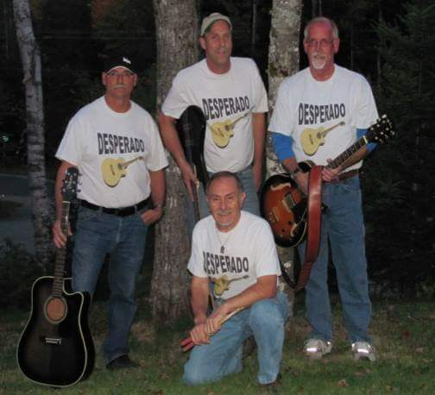

**All proceeds going to the Charlotte County Hospital Foundation**

Fundraising Dance

Featuring the Music of

“DeSperado”

